|  |  |  |
| --- | --- | --- |
|  | **Nullclass Edtech Pvt Ltd** |  |



**PROJECT REPORT ON**

**“ Twitter Analytics Dashboard – Power BI ”**

**A Project submitted to**

**Nullclass Edtech Pvt Ltd**

**By:**

**Mayuri Tukadiya**

**June 2025**

**INDEX**

|  |  |  |  |
| --- | --- | --- | --- |
| **Sr.no** |  | **Content** | **Page No.** |
|  | **Abstract** | | **1** |
| **1** | **Introduction of Company** | | **2** |
|  | 1.1 | Introduction |  |
|  | 1.2 | Services offered |  |
|  | 1.3 | Company Websites |  |
| **2** | **Introduction of “Twitter Analytics”** | | **3-8** |
|  | 2.1 | Introduction |  |
|  | 2.2 | Purpose |  |
|  | 2.3 | Scope of project |  |
|  | 2.4 | Advantage |  |
|  | 2.5 | Problem statement |  |
|  | 2.6 | Goal |  |
|  | 2.7 | Literature Survey |  |
|  | 2.8 | Limitations |  |
|  | 2.9 | Technologies Used |  |
|  | 2.10 | Limitations |  |
| **3** | **Designs** | | **9-18** |
|  | 3.1 | Dataset (Before Transform) |  |
|  | 3.2 | Transformed Tables |  |
|  | 3.3 | Visuals |  |
|  | 3.4 | Dashboard |  |
| **4** | **Conclusion** | | **19** |
| **5** | **Future Scope** | | **20** |
| **6** | **Reference** | | **21** |
|  |  |  |  |
|  |  |  |  |

**ABSTRACT**

## In the era of digital communication, analyzing social media engagement is crucial for understanding audience behavior and optimizing content strategies. This project presents a Twitter Analytics Dashboard built using Power BI to visualize and interpret tweet interactions effectively.

By integrating multiple visualizations into a single interactive dashboard, this project offers a structured and insightful representation of Twitter engagement patterns. The application of data analytics techniques enables users to make data-driven decisions and enhances understanding of how different factors impact tweet performance. This project demonstrates the power of Power BI in processing, filtering, and visualizing social media data to derive actionable insights.

## The objective is to provide meaningful insights into tweet performance, helping users identify trends and improve social media strategies. Overall, this Twitter Analytics Dashboard serves as a valuable decision-making tool, offering actionable insights into social media engagement trends.

**Chapter : 1**

**INTRODUCTION OF COMPANY**

* 1. **Introduction**

NullClass Edutech Pvt Ltd is an innovative educational technology company dedicated to bridging the gap between theoretical knowledge and practical application. The company focuses on providing real-world training, hands-on projects, and industry-relevant courses to equip learners with the necessary skills to excel in various domains such as software development, data science, and cybersecurity.

* Focuses on practical learning rather than just theory
* Provides real-world project experience
* Offers opportunities for students to work on live industry projects
* Builds job-ready skills for a competitive career in tech
  1. **Services Offered**

1. **Online Educational Courses** – Self-paced video courses on programming, data science, web development, cybersecurity, and more.
2. **Real-Time Project Tasks** – Hands-on assignments that allow students to apply theoretical concepts in real-world scenarios.
3. **Internship Training Programs** – Paid and unpaid internships offering industry-relevant experience in domains such as AI, machine learning, web and app development.
4. **Cybersecurity Labs** – Practical cybersecurity and ethical hacking training for those interested in security research.
   1. **Company Website & Social Links**

* **Website :** [www.nullclass.com](https://www.nullclass.com)
* **LinkedIn :** [NullClass on LinkedIn](https://in.linkedin.com/company/nullclass)

**Chapter : 2**

**INTRODUCTION OF “TWITTER ANALYTICS DASHBOARD”**

1. **Introduction**

* The Twitter Analytics Dashboard Project was undertaken to analyze Twitter engagement metrics and uncover trends, patterns, and correlations within the data.
* The project involved extensive data preprocessing, cleaning, and visualization using Power BI, DAX, and Power Query, ensuring real-time filtering and interactivity for better insights. This report outlines the processes, tools, challenges, and outcomes encountered during the development of the dashboard.
* Additionally, it highlights key learnings, skill advancements, and the impact of data-driven analysis in understanding social media engagement.

1. **Purpose**

* The purpose of this Twitter Analytics Dashboard Project is to analyze Twitter engagement metrics such as likes, retweets, replies, and media views to gain meaningful insights into user interactions. By leveraging Power BI, DAX, and Power Query, this project helps in:
  + **Identifying Engagement Trends**: Understanding how users interact with tweets over time.
  + **Comparing Engagement Metrics**: Analyzing the relationship between likes, retweets, and replies.
  + **Improving Data-Driven Decision-Making**: Providing insights for optimizing social media strategies.
  + **Enhancing Data Visualization Skills**: Developing an interactive and real-time dashboard using Power BI.
  + **Filtering and Analyzing Data Efficiently**: Using advanced filtering techniques to focus on specific insights.

This project helps businesses, marketers, and analysts track social media performance, optimize content, and make informed decisions based on data.

1. **Scope of the Project**

* The Twitter Analytics Dashboard Project focuses on analyzing Twitter engagement metrics using Power BI, DAX, and Power Query to provide meaningful insights. The scope of this project includes:
* **Data Collection & Processing**: Extracting and cleaning Twitter data for accurate analysis.
* **Engagement Analysis**: Measuring likes, retweets, replies, and media views to understand user interactions.
* **Data Visualization**: Creating an interactive Power BI dashboard for easy interpretation of trends.  
  **Trend Identification**: Analyzing patterns in Twitter engagement over time.
* **Performance Comparison**: Comparing different tweets based on engagement metrics.
* **Interactivity & Filtering**: Applying dynamic filters for real-time insights.
* **Decision-Making Support**: Assisting businesses, marketers, and analysts in optimizing Twitter strategies.

1. **Advantages**

* The Twitter Analytics Dashboard Project provides several key benefits in analyzing Twitter engagement metrics. By leveraging Power BI, DAX, and Power Query, this project helps in gaining meaningful insights for better decision-making.

1. **Improved Social Media Insights**
   * Helps understand how users engage with tweets through likes, retweets, and replies.
   * Provides a clear comparison of engagement metrics to track performance.
2. **Data-Driven Decision Making**
   * Enables informed decisions on content strategy based on real engagement data.
   * Helps businesses, influencers, and marketers optimize their Twitter activity.
3. **Business & Marketing Optimization**
   * Helps marketers create more effective campaigns and strategies.
   * Assists businesses in targeting the right audience based on engagement insights.
4. **Trend Identification & Performance Tracking**
   * Helps track which type of tweets get the most engagement over time.
   * Identifies the best-performing content to refine social media strategies.
5. **Problem Statement**

* In today’s digital age, social media platforms like Twitter generate massive amounts of engagement data, including likes, retweets, replies, and media views.
* However, analyzing this data manually is time-consuming and inefficient.
* Businesses, marketers, and content creators often struggle to identify which tweets perform well, what factors drive engagement, and how to optimize their content strategy.

1. **Goal**

* The primary goal of this Twitter Analytics Dashboard Project is to develop an interactive Power BI dashboard that provides meaningful insights into Twitter engagement metrics, such as likes, retweets, replies, and media views. The project aims to help users analyze trends, compare engagement performance, and make data-driven decisions to improve social media strategies.

Through data cleaning, transformation, and visualization, this project

seeks to:

* Understand user engagement patterns by analyzing interactions on tweets.
* Identify high-performing content based on engagement metrics.
* Provide an intuitive and interactive dashboard for real-time analysis.
* Enhance decision-making by offering insights into content optimization.
* Develop skills in Power BI, DAX, and data analytics by applying real-world data analysis techniques.

1. **Literature Survey**

* The field of social media analytics has gained significant attention in recent years due to the increasing reliance on platforms like Twitter for communication, marketing, and public engagement.
* Several studies and research papers highlight the importance of analyzing Twitter data to understand audience behavior, optimize content, and improve engagement strategies.
* Twitter Engagement Metrics and Their Impact

Engagement metrics such as likes, retweets, and replies are key indicators of audience interaction. Research by Boyd, Golder, & Lotan (2010) highlights that retweets play a crucial role in content amplification, spreading information beyond the original audience. Furthermore, a study by Pew Research Center (2019) indicates that tweets with images, videos, or links tend to have higher engagement rates than text-only posts.

1. **Limitations**

* **Platform-Specific Analysis** – The dashboard is built only for Twitter and does not consider engagement on other social media platforms like Facebook, Instagram, or LinkedIn.
* **External Factors Not Considered** – The analysis does not account for external influences such as trending topics, viral events, or changes in Twitter’s algorithm that could affect engagement.
* **User-Specific Insights Are Limited** – The dashboard provides general engagement trends, but it does not personalize insights based on individual user preferences or specific audience segments.

1. **Technologies Used**

* **Power BI (Microsoft Power BI)**
  + Used for data visualization and dashboard creation. Enables interactive filtering, data exploration, and report generation.
  + Provides dynamic visuals to compare engagement metrics (likes, retweets, replies, media views).
* **DAX (Data Analysis Expressions)**
  + Used to create calculated measures and columns for better data insights.
  + Helps in aggregating, filtering, and transforming data efficiently.  
    Examples include engagement rate calculations, comparisons, and trend analysis.
* **Power Query (M Language)**
  + Used for data extraction, transformation, and loading (ETL) in Power BI.
  + Cleans and preprocesses data by removing duplicates, handling missing values, and filtering records.  
    Helps in reshaping and merging datasets for better analysis.
* **Data Source (CSV / Excel / Database)**
  + The Twitter data is imported from structured datasets (e.g., CSV, Excel, or databases).
  + Enables efficient storage and retrieval of engagement metrics.
* **Data Modelling Techniques**
  + Establishes relationships between tables to enable seamless filtering and interaction.
  + Helps create a structured data model for better insights.

1. **Limitations of the Existing System**

* **Limited Data Customization** – Cannot filter tweets based on specific conditions (e.g., odd-numbered dates, even media views).
* **No Advanced Visualization** – Twitter Analytics and spreadsheets lack interactive charts and dashboards.
* **Static Data Analysis** – Most tools do not allow **dynamic filtering and real-time insights.**
* **High Cost for Third-Party Tools** – Many advanced tools require **premium subscriptions,** which may not be affordable for all users.

**Chapter : 3**

**DESIGNS**

**3.1 Dataset (Before Transform)**

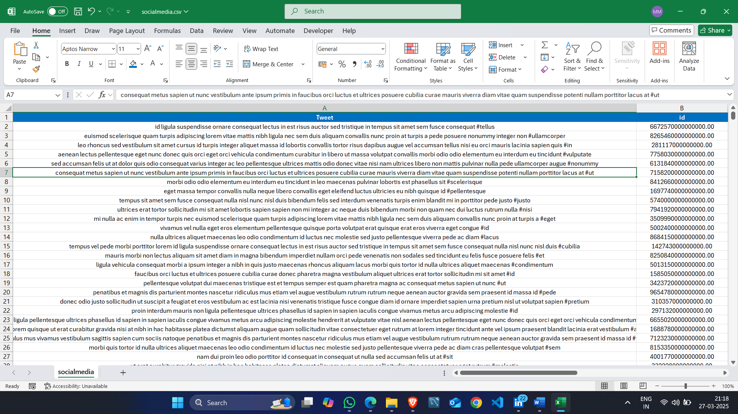

**3.2 Transformed Table**

**1) socialmedia**

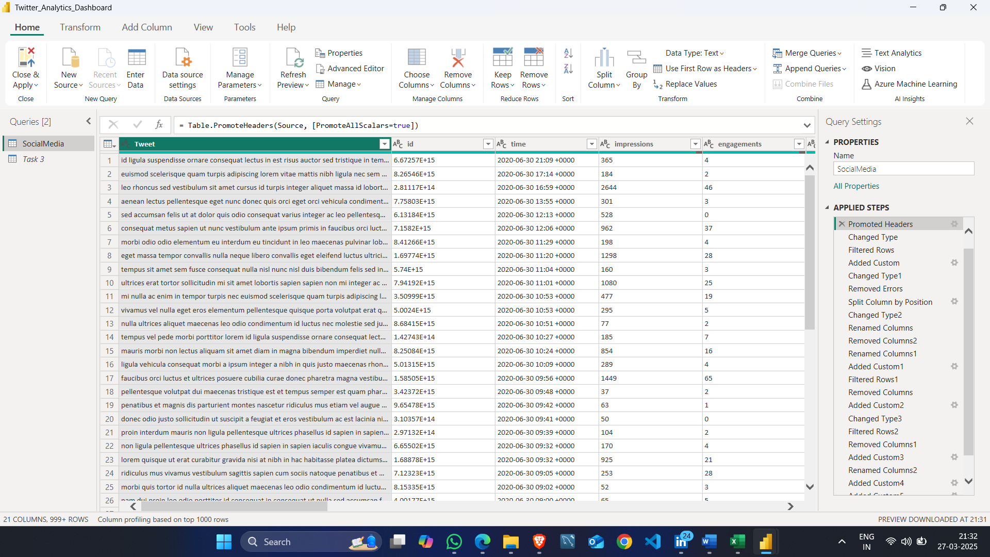

**2) Click Types**

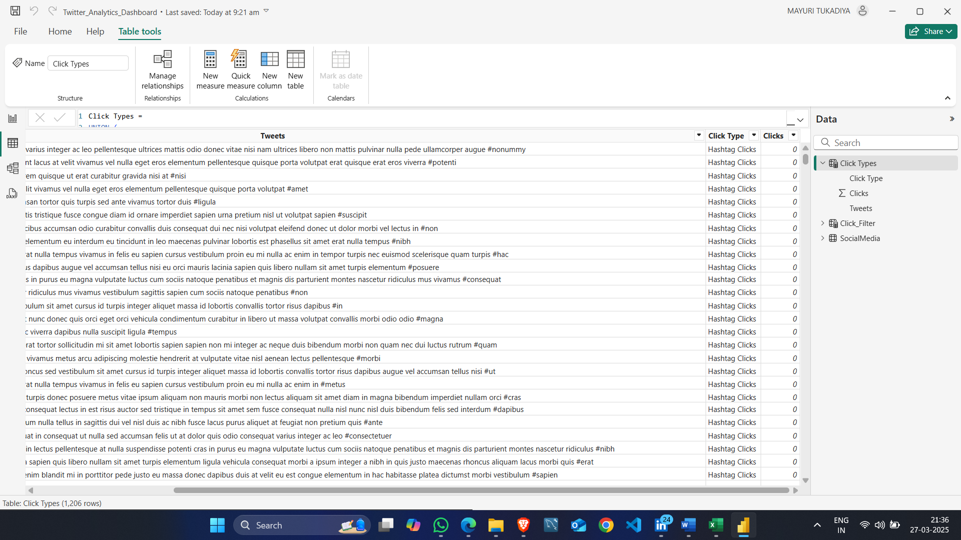

**3) Click_Filter**

**3.3 Visuals**

**1) Stacked Bar Chart**

**2) Pie Chart**

**3) Stacked Bar Chart**

**4) Scatter Chart**

**5) Clustered Bar Chart**

**6) Line Chart**

**7) Clustered Column Chart**

**8)Stacked Column Chart**

**9) Line Chart**

**3.4 Dashboard**

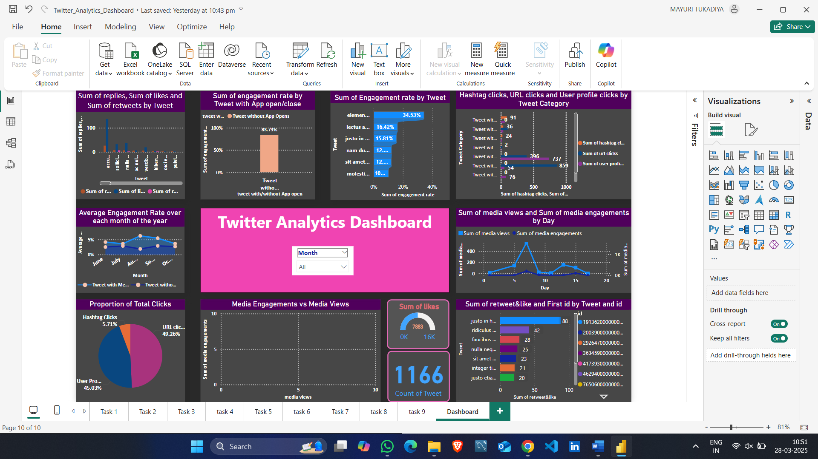

**Chapter : 4**

**CONCLUSION**

**Conclusion**

The Twitter Analytics Dashboard Project successfully provides a structured and interactive approach to analyzing Twitter engagement metrics, helping users gain valuable insights into likes, retweets, replies, and media views. By leveraging Power BI, DAX, and Power Query, the project enables automated data processing, dynamic filtering, and real-time visualization, making it more efficient than traditional manual tracking or built-in Twitter analytics tools.

This project highlights the importance of data-driven decision-making in optimizing social media strategies. Through interactive dashboards, users can identify trends, engagement patterns, and high-performing content, leading to better content planning and audience engagement. Additionally, the project provides hands-on experience in data analytics, visualization, and business intelligence, enhancing technical and analytical skills.

Despite certain limitations, such as the lack of real-time data integration and sentiment analysis, the project lays the foundation for further improvements, including API integration, predictive analytics, and cross-platform social media analysis. Overall, this project demonstrates the power of data analytics in social media management, offering valuable insights that can be used by businesses, influencers, and researchers to enhance their Twitter strategies.

**Chapter : 5**

**FUTURE SCOPE**

The Twitter AnalyticsDashboard Project has provided valuable insights into Twitter engagement metrics, but there is significant potential for further improvements and enhancements. Future developments can enhance the dashboard's functionality, accuracy, and scope to provide deeper insights and real-time analytics.

**1. Real-Time Data Integration**

* Implementing Twitter API to fetch live data instead of relying on static datasets.
* Enabling real-time updates on engagement metrics for up-to-date analysis.

**2. Sentiment Analysis**

* Incorporating Natural Language Processing (NLP) to analyze tweet sentiment (positive, negative, neutral).
* Understanding emotional impact and audience reactions to different types of tweets.

**3. Advanced Predictive Analytics**

* Using machine learning models to predict future engagement trends based on historical data.
* Identifying best posting times, trending topics, and content strategies.

**4. Multi-Platform Social Media Analytics**

* Expanding the project to analyze other social media platforms (e.g., Facebook, Instagram, LinkedIn).
* Comparing cross-platform engagement to optimize content strategies.

**Chapter : 6**

**REFERENCE**

* Microsoft Power BI Case Studies. (2021). How businesses leverage Power BI for social media analytics. Retrieved from [www.microsoft.com/powerbi](https://www.microsoft.com/powerbi)
* Twitter Developer Documentation. Understanding Twitter API limitations and data extraction. Retrieved from [developer.twitter.com](https://developer.twitter.com)
* LinkedIn Learning – Power BI Essential Training